Chapter 15, Problem 27.

Determine the inverse Laplace transform of each of the following functions:

(a) 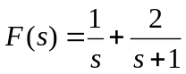
(b) 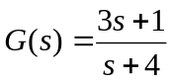
(c) 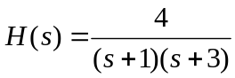
(d) 